# Software Development Plan

## CS 3300-002 Spring 2025

Jack Dodge, West Manison, George Morales, Sebastian Sanchez

## Project Title:

John Doe Portfolio

## Project Description:

A fully functional website portfolio that demonstrates a clear ability to create and showcase a collection of projects. The website should be easy to use and should allow the user to feel confident in John Doe’s software engineering capabilities. The website will also contain links to faux social media websites and contact pages, to simulate what a true software engineer portfolio could look like.

## Problem to be Solved:

Our team wanted to answer the question: how do you stand out in a growing and competitive job market? Our answer was a customized website portfolio that shows skills and interests in a ‘marketable’ way.

## Software functionality being developed:

Below is a compilation of the functional components of the projects we are going to be developing as well as some technology we are planning on using.

1. Primary functions:
   1. Website accessible to anyone, on any device
   2. Four functional games/programs (blackjack, encryption/decryption, snake, and tic-tac-toe)
   3. Links to social media websites
   4. Functional contact forms
2. Languages
   1. HTML
   2. CSS
   3. JavaScript
   4. Python (if the above three languages are not extensive enough)
3. Host/DNS provider:
   1. GitHub Pages
   2. Go Daddy
4. Compilers
   1. N/A

## Configuration Management:

This will be managed by our software requirements and timeline sheet, allowing us to understand what components of the project are required to accomplish the necessary goals. Our prioritization of the primary functions looks like:

1. Get a website up and running
2. Build and test functional games/programs
3. Implement those into the functional website and test further
4. Implement extra functionality (i,e. contact pages, view source code options, etc.)
5. Finalize style and minor bugs at the end

## Risk Management:

We have identified two major risks, Scope Creep and Communication between team members. Below are the ways we intend to mitigate these risks as best as possible:

* **Scope Creep**: To manage this, we will attempt to stick closely to our initial functional and non-functional requirements and avoid adding new features unless the original scope is fully completed ahead of schedule.
* **Communication**: Since our team members all have different availability, we will set clear deadlines and check-in points to ensure consistent communication

## Engineering Planned Approach:

We are planning to use a test-driven development (TDD) model. This means that for each subproject, we will first define expected outputs and test cases before developing the code. By doing this, we ensure that our code is not only robust and intentional, but also completely ensures that is in line with our long term desired outcomes.

## Schedule:

This is a screen capture of our initial schedule for our project. This document does not only hold our general schedule/timeline but also holds our testing requirements. We chose to consolidate these into a single document to ensure ease of access and to make it simple to track progress and identify where support may be needed.

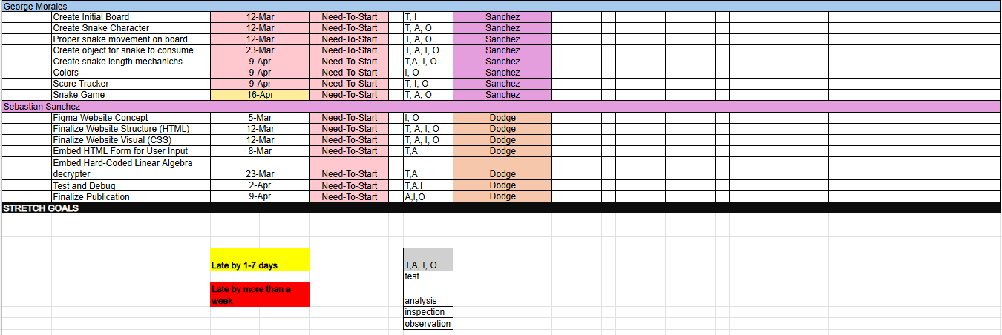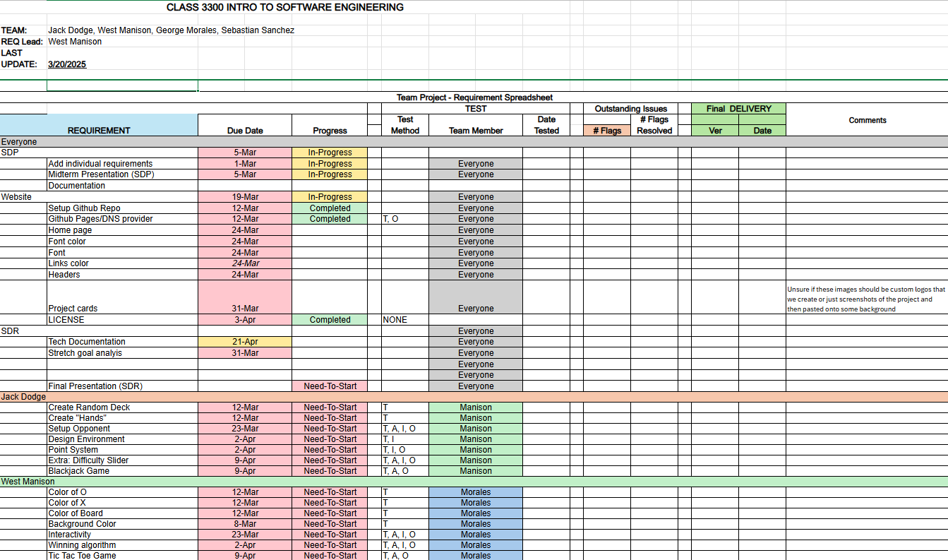

Note: A major team check-in is scheduled for the week following spring break. At that time, we will review each member's progress and, depending on our status, discuss potential stretch goals for the remainder of the project.

## Team Members and our responsibilities:

Below are all members and their assigned roles/responsibilities:

Jack Dodge:

* Developer (build blackjack project)
* Tester
* Product owner

West Manison:

* Developer (build tic tac toe game)
* Tester
* Test Coordinator
* Co tech-writer
* Refine code postproduction to ensure continuity between sub-projects

George Morales:

* Developer (build snake game)
* Tester
* Lead-tech writer
* Team Coordinator

Sebastian Sanchez:

* Developer (build encryption program)
* Tester
* UI/UX Developer (help setup initial HTML docs and support other team members)

*Note:* Since we are each developing individual subprojects that must integrate into one cohesive website, all team members will be ‘wearing many hats’ as needed to support each other and ensure every project is fully developed prior to the final integration.